
ANAND
INTERNATIONAL COLLEGE OF ENGINEERING
Near Kanota, Agra Road, JAIPUR-303012, Phone: 01429-234994, 234995
Ref. No.: AICE/Exam-Cell/Notice/2026/42 Date: 07/10/2026

NOTICE
All the students are hereby informed that the RTU Revaluation/View Copy Form is available to filling up online for B.Tech II and IV Semester (Main/Back) Exam 2025-26. Student, who wants to fill revaluation/view copy form may apply through the Online Revaluation/View Copy Form on or before 14/10/2026.

Note:-
- Revaluation fee per paper: Rs.850
- View Copy fee per paper : Rs.1000
- Student may apply Revaluation and View Copy simultaneously.
- Student may apply for Revaluation in 2 appeared papers.
- Student may apply for Copy View in all appeared papers.
- Fill Revaluation and View Copy form online and pay applicable fee before the

Last date: 14/10/2026.

NOTE: Fee can be deposited through the given form link/qr code in notice only.
Payment of fee through the other mode will not be accepted.

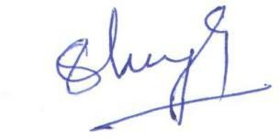

Controller of Examination

Cc to:

- Hon’ble Chairman Sir – for kind information
- Hon’ble VC Madam – for kind information
- Respected Principal sir – for kind information
- Respected Vice Principal sir – for kind information
- All Notice Board
- Accounts
- Office file
Visit https://anandice.ac.in/enotices/ for e-notices. Form QR Code

